Ecommerce Website For Online
Electronics Store

T. E. Information Technology

By

Group No. - 03

Hrithik Patil 12
Leander Pereira 16
Rahul Pereira 17

Guide
Ms. Purnima Kubde
Assistant Professor



Department of Information Technology
St. Francis Institute of Technology
(Engineering College)

University of Mumbai

2020-2021

INDEX
Sr. No. | Content | Page No.
 | Work Done | 3-4
 | Website proposal | 5-8
3. | Requirement Analysis | 5-8
4. | Design | 9-12
5. | Output (Screenshot and Description) | 15-18
6. | Conclusion | 13-20
7. | Work Distribution | 21
8. | References

Signature:

Ms. Purnima Kubde
(Internal Guide)

Activity Completed

Activity Completed
Sr. No. | Activity | Status | Remarks
1 | Formulate a web design proposal containing requirement analysis | Yes
2 | Create a webpage using HTML and different types of CSS | Yes
3 | Perform form validation using JavaScript and design a skeleton for website | Yes
4 | Design a Web Layout Using RWD Framework demonstrating HTML5 features like embedding audio, video, geolocation and accessibility | Yes
5 | Demonstrate CSS3 transition, transformation, animation, aesthetics and responsive form in your website. | Yes
6 | Mid Term Project Evaluation | Yes

Weekly Activity (Semester End)
Sr.  No. | Activity | Date
7 | Create and connect database with mini project by using PHP and MySQL. | 23/10/20
8 | XML -  a) Use XSLT elements  b) Create XML Schema | 30/10/20
9 | AJAX & JSON -  a) Develop and design RIA using AJAX  b) Access a JSON file | 6/10/20
10 | Host website using any free web domain. | 19/11/20
11 | Final Project Evaluation | 26/11/20

Signature:

Ms. Purnima Kubde
(Internal Guide)

Project Report
Section 1 - Web Design proposal

PROJECT REPORT
Section 1 - |  | Web design proposal
1. | Website Title - | E-Commerce for Online Electronics shopping. (Easy Electronics)
2. | Overview - | The main idea of designing this website is to allow the customers to shop virtually and more conveniently by sitting at their home and buying the different products they need at a click of a button .The website that we will be designing will be very similar to the various online shopping websites where in there will be a wide range of products which are categorized into different sections based on their need. Also there is a shopping cart option where in once a customer likes a particular product he/she can add it to the cart for later purchase. The website also includes a checkout gateway for purchasing the products which are stored in the shopping cart. Once the customer is onto the checkout section a basic transaction procedure is carried out where the customer has to enter their address and payment method etc for the final delivery to the address submitted by them.
3. | Need of the Project- | The need for creating this project is to allow the customers to shop conveniently by saving much of their time which is wasted during shopping the similar product offline. By the help of this project we are providing comfortable services to the customers by allowing them to save their items in a personalized shopping bag and buy them later. There is also wide variety of products which the customers can choose from and also compare between the specifications of these products and then finally purchase the best product which satisfy their needs.
4. | Objective - | - Providing convenient payment methods.  - Providing 100% satisfaction to the customers for the goods purchased.  - Providing customer care helpline services.  - Easy return and replacement process of the defective goods purchased.  - Customers are able to choose from the variety of products easily and have more choice of products.

5. | Problem statement- | - Wastage of time while purchasing the products offline.  - Customers have very limited payment options.  - Customers do not have the option of purchasing the item later on in future which may not be available.  - Difficult or No return policy.  - No ratings provided of new products where in customers can get cheated easily.
6. | Problem Solution | This project aims to develop an online electronics shopping site for the customers with the goal to allow the customers to have a variety of products they can choose to buy from. With the help of this website the customers can purchase the necessary products they need sitting at their home and also be assured of the quality of the product delivered to them. Her you simply require a pc, phone or laptop and one important payment sending option for purchasing your desired product.

Section 2 – Requirement Analysis

Section 2 - |  | Requirement Analysis
1. | Target Audience - | - Our main target will be those people who are busy and do not get much time to buy the product offline.  - Commercial businesses who are mostly in need of various electronic products.  - Children of age group 16 and above who typically use gadgets such as mobiles, laptops, tablets and various other accessories etc.
2. | Features Required - | The different features that are website provides are as follows:  - Various payment methods.  - The customer can create an account in the website for easy use of it’s services.  - Product Rating.
3. | Software and Hardware requirements - | - Software requirements –  - Hardware requirements –
  1. | Operating System | Windows, Mac, OS
  2. | Brackets | Brackets
  3. | Web Browser (google chrome) | Google chrome
  1. | RAM | 8Gb
  2. | Intel processor | Intel i5
  3. | CPU | 82500U 1.60GHz
  4. | Internet connection
4. | Sites referred - | Leander Pereira: www.croma.com  Hrithik Patil: paytmmall.com  Rahul Pereira: www.reliancedigital.in

- Introduction of the topic selected for the website.

This project is made on HTML/PHP based on the topic Ecommerce website for an electronics store. This project covers all aspects of online shopping of the electronic appliances. In this website there is also an about us page where the user can get to know more about our website. Our website also has a 24hr customer support section where the user can contact us if any query or difficulties. Our website also features an FAQ page where the users can get answers to some of their basic questions. Thus through this project customers can easily buy whatever they need sitting at home. Also they can buy them at reasonable rates.

- Problem and problem solution description

This project aims to develop an online electronics shopping site for the customers with the goal is to help them purchase them whatever products they like and need comfortably. With the help of this website they can purchase any appliance/product from home and get a guarantee in the quality for the products their purchasing. If they face any problem they can contact us through the 24hr customer care page. You simply require a pc, phone or laptop and one important payment sending option for purchasing your desired things. The features included in the forms of an application are as follows:

• We allow the customer to have COD as a payment option
•The website's user interface is extremely good so that customer will not face any issues while handling the website.
•The customer can make an account in for his/her future ease of payments, delivery and suggestions.

- Description of features selected for the website and the target audience.

Our website provides a huge collection of electronic appliances which can be purchased online at the ease of sitting at home and getting the delivery at home itself. User interface of website application is so easy that anyone can handle it and no one will face any difficulty in accessing it. The customer can make the account on the website and save his/her details so that every time he/she does not have to give his/her details.

Our website provides features such as:

- Customer rating
- Price
- Customer Support
- FAQ

Wireframes-
Wireframe diagrams with proper figure names and description

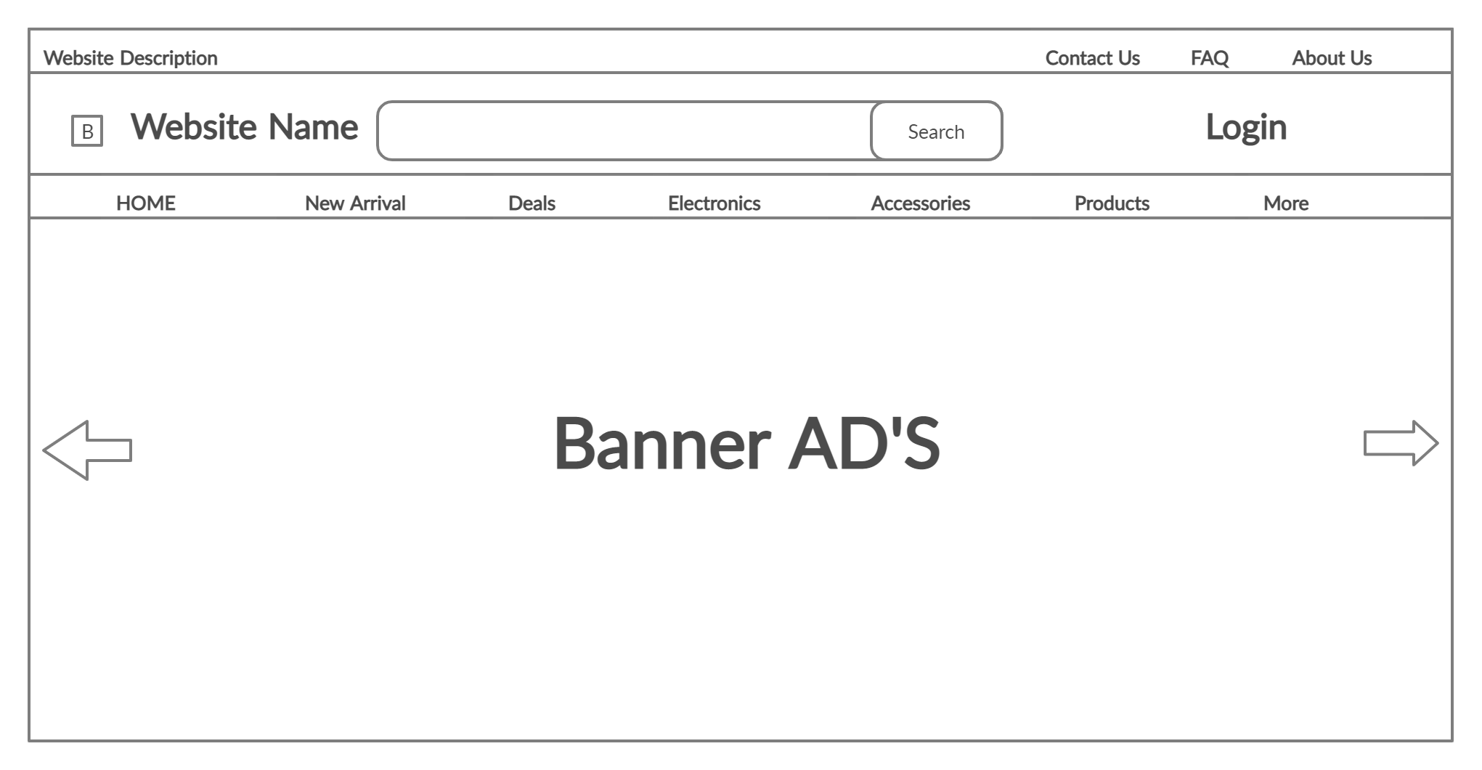
Fig.1: Homepage Wireframe
Description- This is the homepage wireframe where you can see various options to explore.

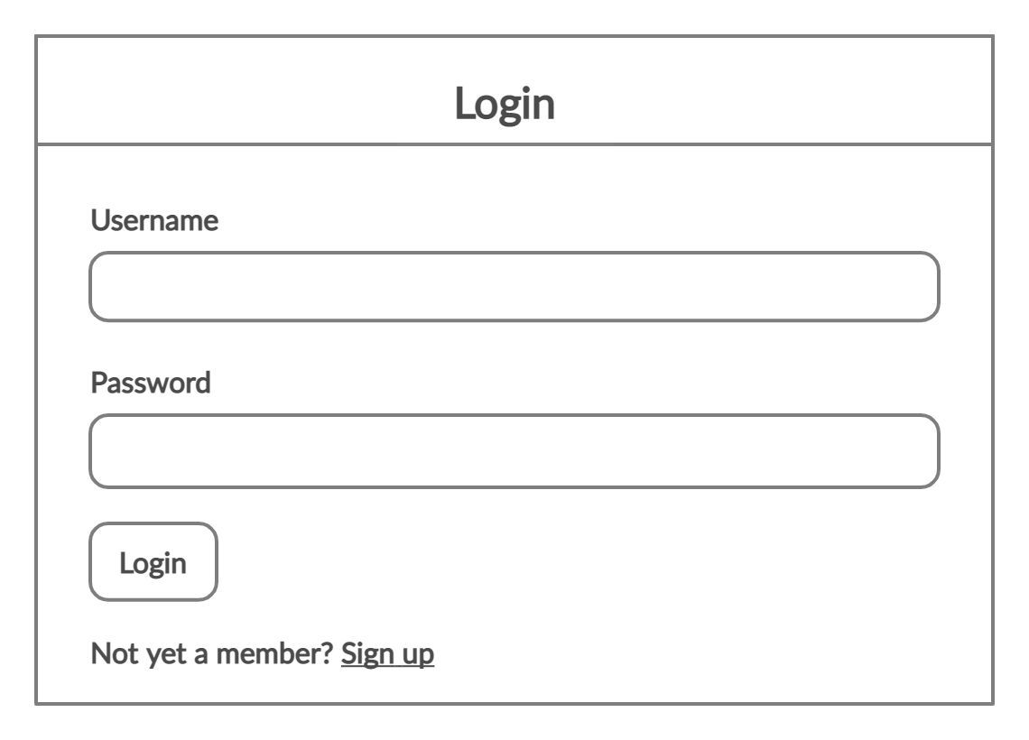

Fig.2: This the wireframe of login page where you can login to the website

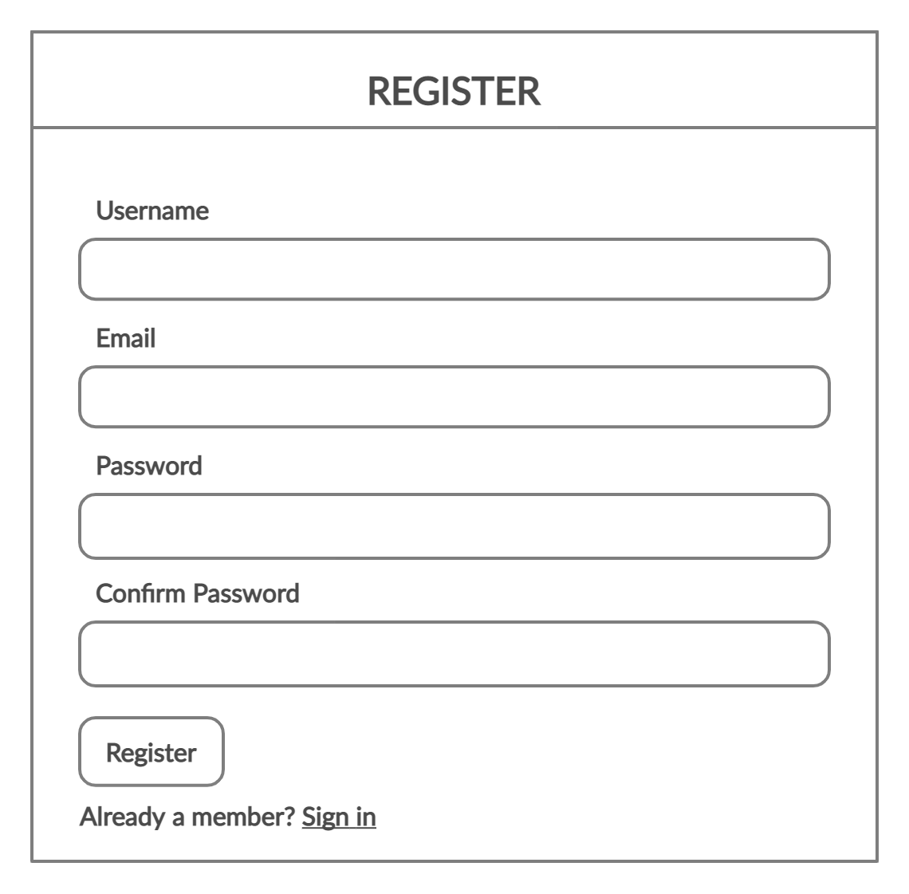

Fig.3: This the wireframe of register page where you can register to the website

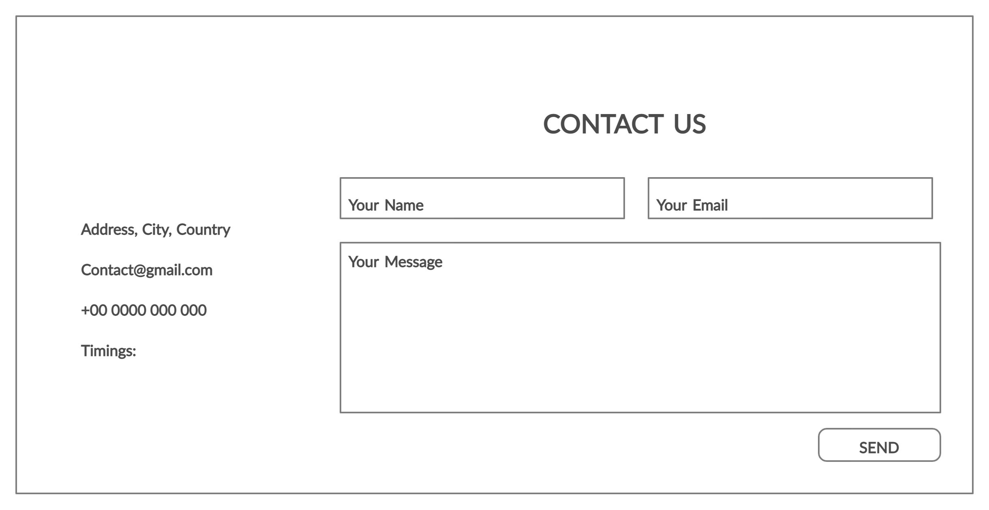

Fig.4: This the wireframe of contact us page where customers can contact us if there are any problem.

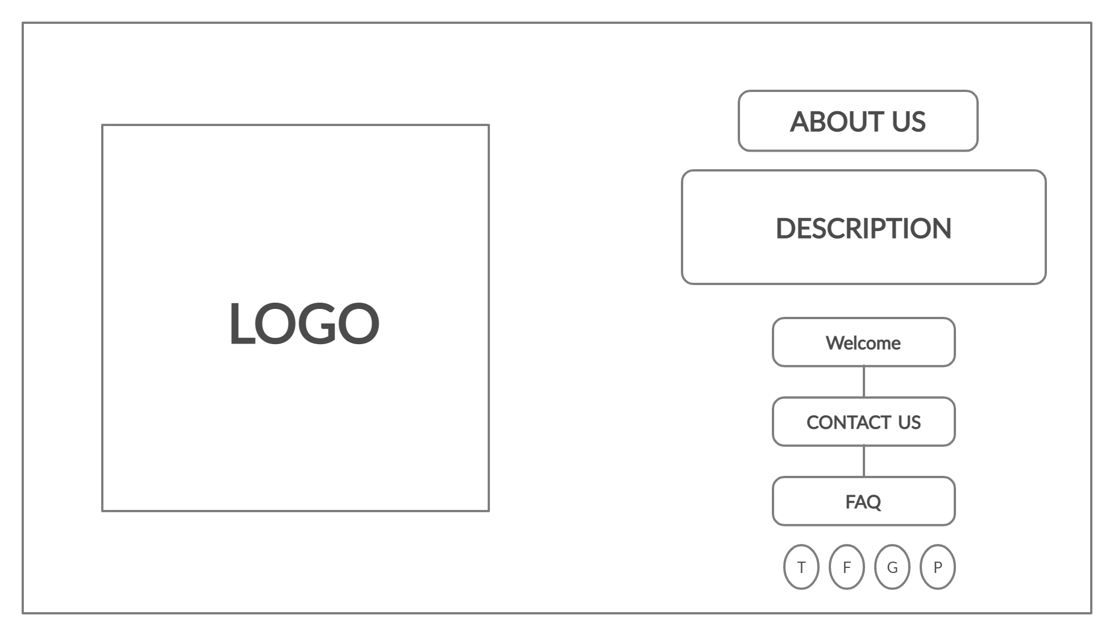

Fig.5: This the wireframe of about us page where the customer can get to know us better and also have information to the terms and conditions of use.

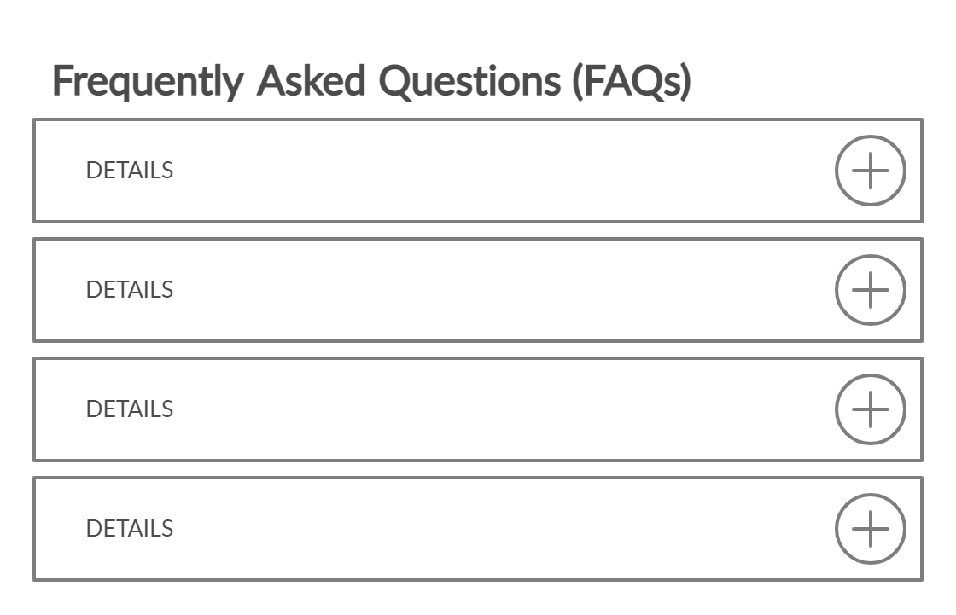

Fig.6: This the wireframe of FAQ page where the customer can get solutions or answers to frequently asked problems or questions about the website.

Blueprint-

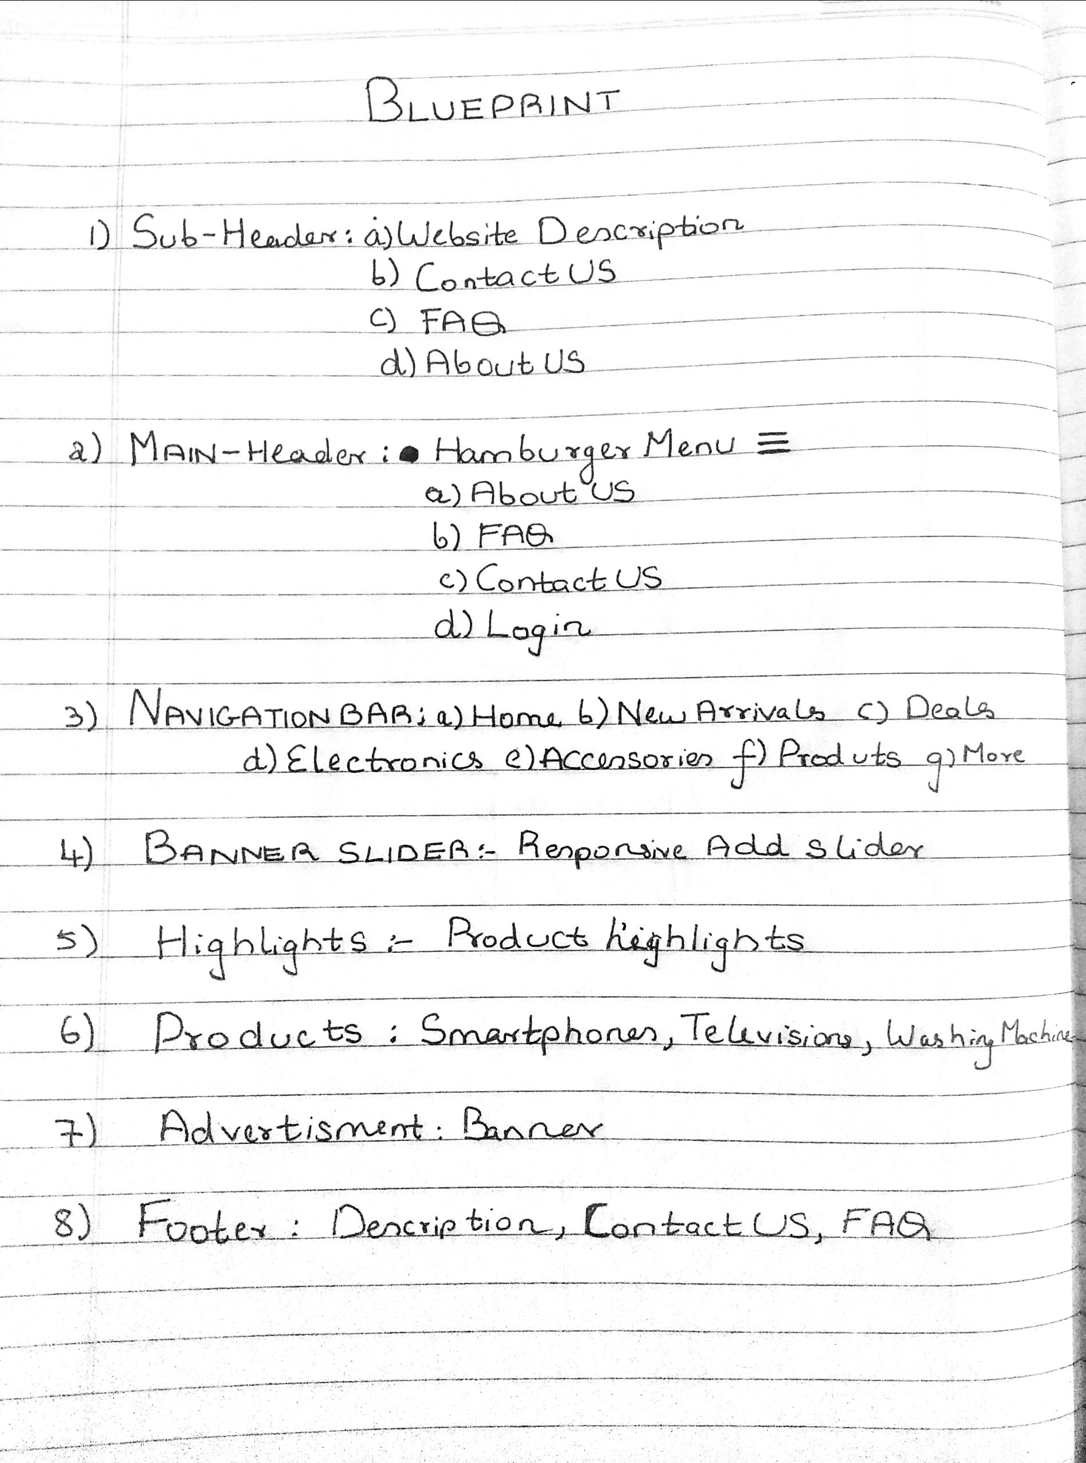
Fig 2:- Blueprint of Homepage

Description:- This the blueprint of the website homepage. This is how the flow of the homepage looks like.

Output
(Screenshot and Description)

OUTPUT-

Figure 1: Home Page

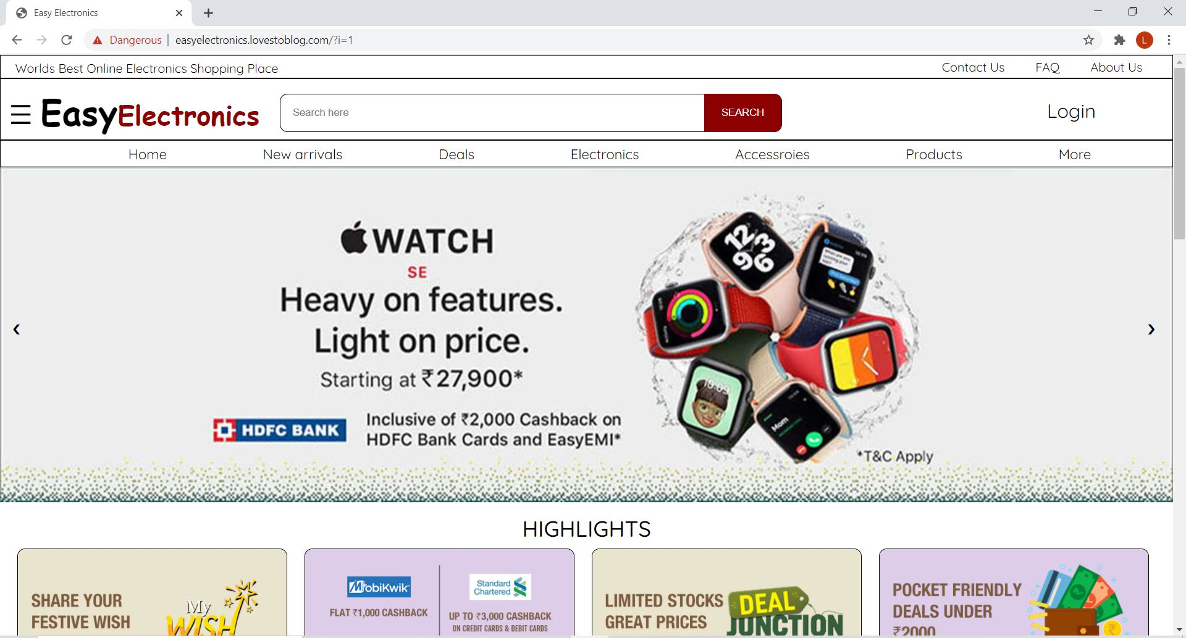

Sr. No. | Feature Used | Technology Used
1 | Navigation Bar | CSS and HTML
2 | Logo | CSS3 and HTML5
3 | Responsive  Slideshow Transition | Viewport and Media screen  JavaScript, CSS3, HTML

Fig 2:- Log in & Sign in Page

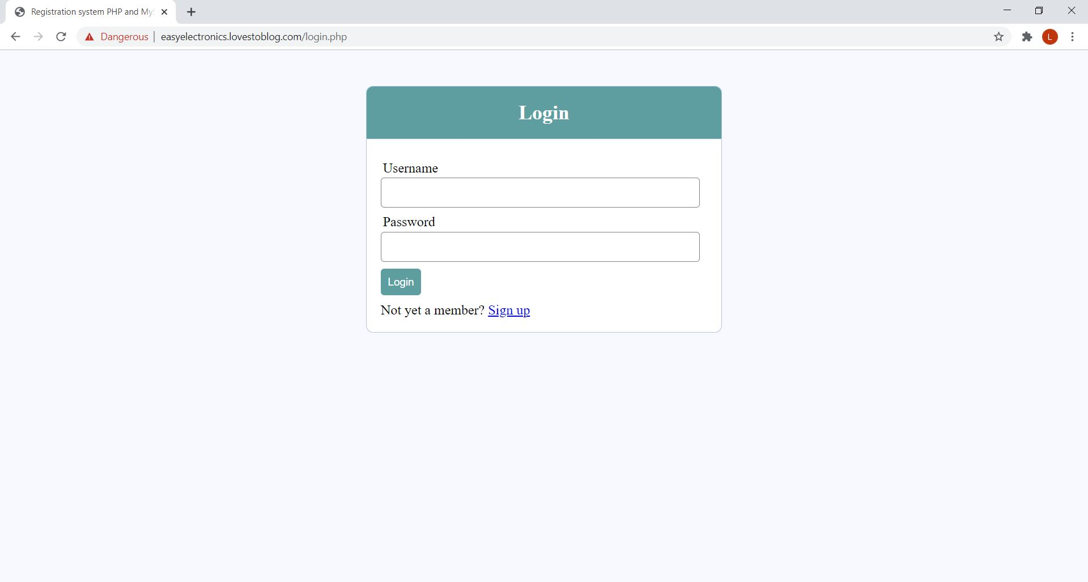

Fig 3:- Log in & Sign in Page

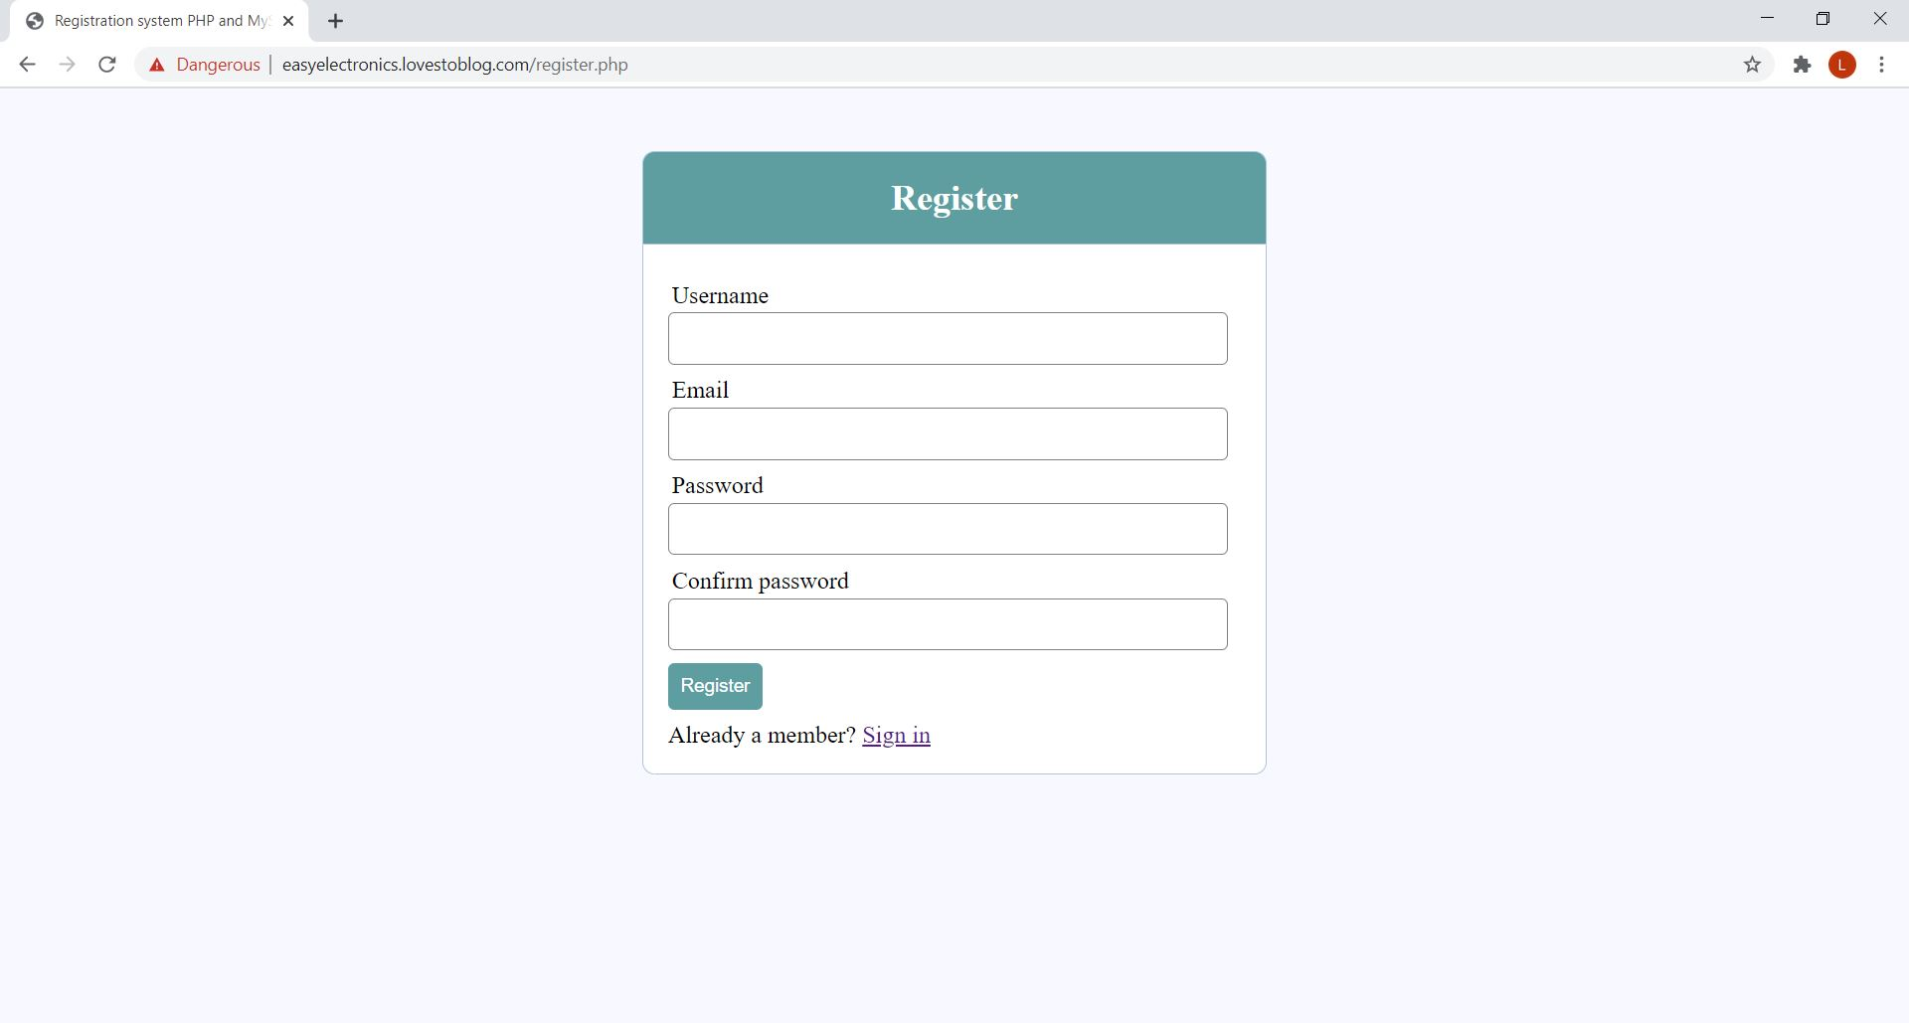

Sr. No. | Feature Used | Technology Used
1 | Database | SQL
2 | Responsive | Viewport
3 | Buttons | CSS and HTML

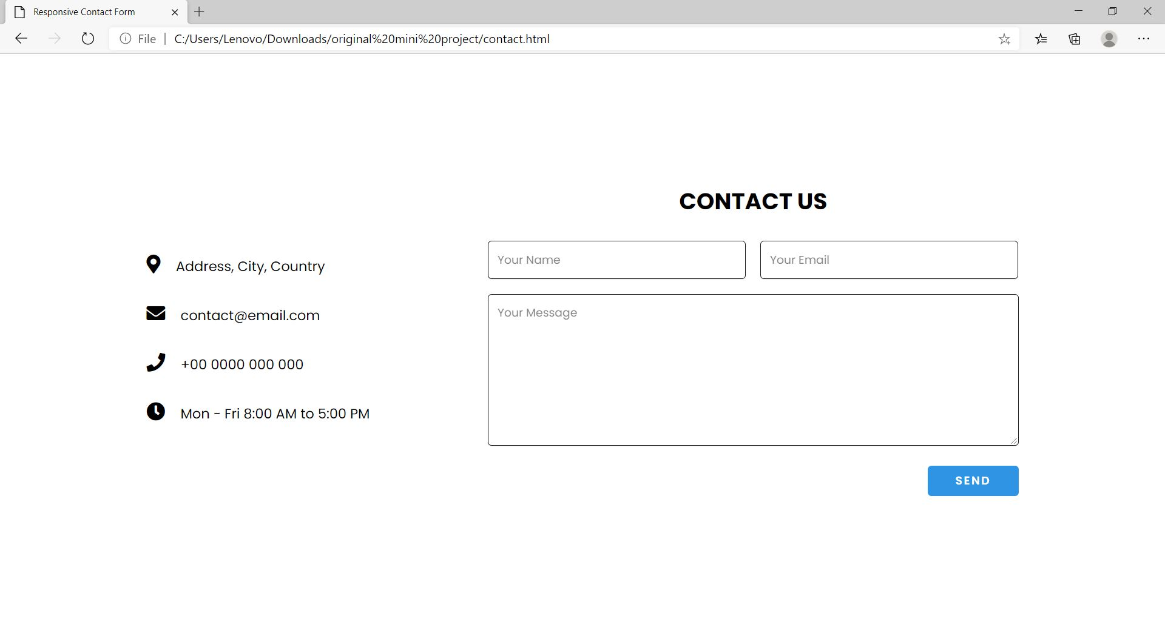
Fig 4:- Contact Us Page

Sr. No. | Feature Used | Technology Used
1 | Design | HTML/CSS3
2 | Mailing Feature | PHP
3 | Responsive | Viewport
4 | Button/Label | HTML/CSS

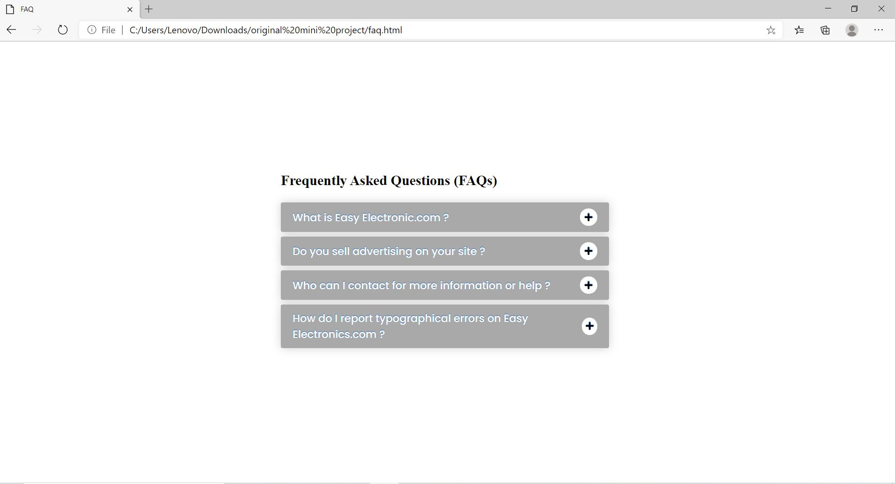
Fig 5:-FAQ Page

Sr. No. | Feature Used | Technology Used
1 | Place Holder Design | HTML/CSS
2 | Responsive | Viewport
3 | Buttons | CSS and HTML
4 | Text Box | HTML
5 | Transition | CSS3

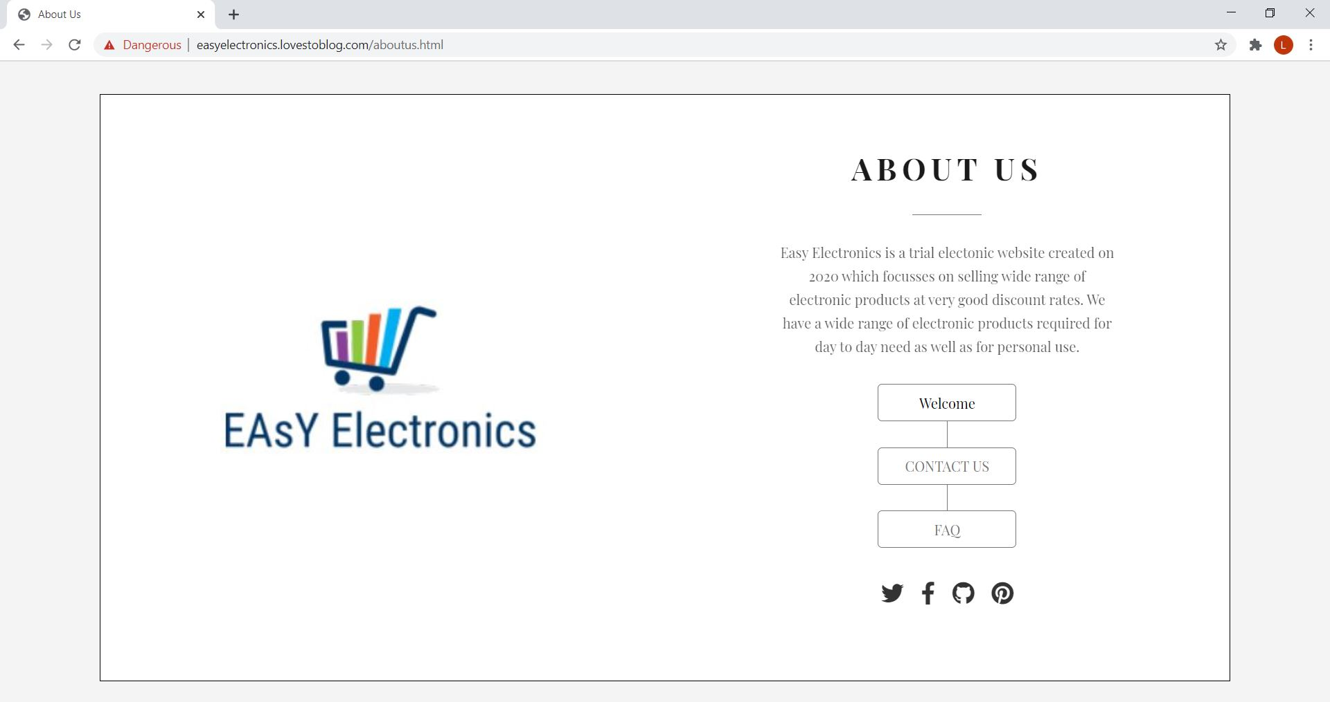

Fig 6:-About Us

Sr. No. | Feature Used | Technology Used
1 | Button/Text | CSS and HTML
2 | Logo | CSS3 and HTML5
3 | Responsive | Viewport and Media screen

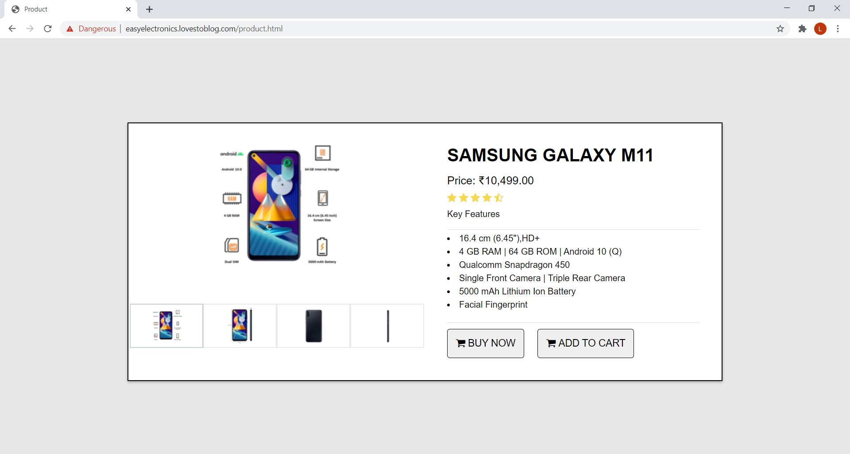

Fig 7:-Product Page:

Sr. No. | Feature Used | Technology Used
1 | Product Information | Java Script
2 | Responsive | Viewport
3 | Buttons | CSS and HTML
4 | Text Box | HTML
5 | Label | HTML5 and CSS3

Steps for hosting our website:-

●Firstly, Open infinityfree.net website which is used for hosting websites.
●Then create your account.
●After the creation process is done, sign in into your account.
●Now type in your website name in the displayed text box and check if the website name is available, if available then choose a domain.
●Open control Panel and scroll down and search for MySql databases and click on that.
●In this case we selected and created a database named registration.
●After creating database click on start now.
●After creating the database we imported our website table from the localhost.
●After the importing process is complete, close the control panel and return to client area.
●Open File manager and upload your website folder and required files from your computer and save the files.
●Go back to your accounts page, your website name shall be displayed. Copy paste the website name in google or any browser URL and run it. You shall then be redirected to your website.

Link of our Website :-

http://easyelectronics.lovestoblog.com/
Conclusion

- Our website provides a huge collection of appliance & products for both household and personal use which can be purchased online at the ease of sitting at home and getting the delivery at home itself with guarantee of the quality of the product delivered.

- Customer rating, Price, Popularity. We also allow the customer to have COD as a payment option.

- The website's user interface is extremely good and the customer will not face any difficult in handling the website.

- The customer can make an account in for his/her future ease of payments, delivery and products suggestions.

- If the user face’s any problem during purchasing or any relayed queries they can contact us on our 24hr customer care service page.

Page/ Modules | Done by
Web Design Proposal | Leander Pereira, Rahul Pereira, Hrithik Patil
Requirement Analysis | Leander Pereira, Rahul Pereira, Hrithik Patil
Wireframe | Hrithik Patil
Blueprint | Leander Pereira
Website Hosting | Rahul Pereira
Home Page | Leander Pereira
Registration Page | Rahul Pereira, Hrithik Patil
Login Page | Rahul Pereira, Hrithik Patil
Highlights Section | Rahul Pereira, Hrithik Patil
Products Page (Details about Product before & after clicking) | Leander Pereira
Footer | Rahul Pereira
About Us Page | Leander Pereira
Contact Us Page | Leander Pereira
FAQ | Leander Pereira
Documentation | Rahul Pereira, Hrithik Patil

References

- Website
- W3 schools Available: https://www.w3schools.com/
- Geeks for geeks Available: https://www.geeksforgeeks.org/
- Decathlon.com Available: https://www.decathlon.com/

- Books
- Fundamental Concepts for Web Development by Roxane Anquetil
- HTML & CSS, and JavaScript & JQuery by John Tucket
- Front-End Developer Handbook — 2019 by Cory Lindley

- Papers
- SerdarDogan ,AysuBetin-Can , VahidGarousi(2014), “Web application testing: A systematic literature review”, The Journal of Systems and Software, G Model No. of Pages 1-28
- Kamini, Silky Sachar, Sonia Suneja(2017), “Review Paper on Mean Stack for Web Development”, International Journal for Scientific Research &Development;Vol. 5, Issue 01; ISSN (online): 2321-0613,pg;497-498.
- Bonny Alex Ninan, Sooraj S. R. and Ananthakrishnan Bhaji, Manoj C., Anoop M. S. , Ratheesh'S.andJooby E(2016), “Literature Review Web Application Designed For Schools and Colleges”, Imperial Journal of Interdisciplinary Research (IJIR),Vol-2, Issue-4, ISSN: 2454-1362, pg, 351-353, http://www.onlinejournal.in

